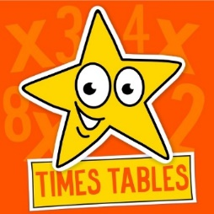
Times Tables Activities
Sing along
2x https://www.youtube.com/watch?v=3yf3xgE8wMc
5x https://www.youtube.com/watch?v=2KyDZ7f1RfE
10x https://www.youtube.com/watch?v=AVdE5O7_qf8
Lucky Dip 
Write out the 2, 5, 10 times tables (2 or all of these).
Cut up each number sentence and put into a pot, box or bag.
Let your child lucky dip to choose a number sentence. Write the answer.
CHALLENGE
Set a timer – 5 minutes to start. How many can your child complete in this time.
Personal Best – can your child improve each time?
Merry Money 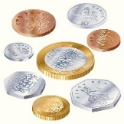
Collect 2, 5 and 10 pence coins.
Make a face with the coins.
Count up the 2p coins -how much altogether? Repeat with 5p and 10p coins.
Make other shapes eg. house, person, pear etc and repeat as above.


