

Growth Mindset and Mind UP
At Wessex Primary School, we know that children who have a positive attitude towards their learning will make good progress and be successful. We want all our children to relish challenges, embrace their mistakes as part of their learning journey, value the importance of effort, respond carefully to verbal feedback and take inspiration from others. This will help them to achieve, not only at school, but also in their future lives beyond Wessex.
In Reception we talk to the children about how amazing their brain is and how their feelings can affect their learning. We explain to the children about how their brain works using animals so that they can relate to it at their level of understanding.

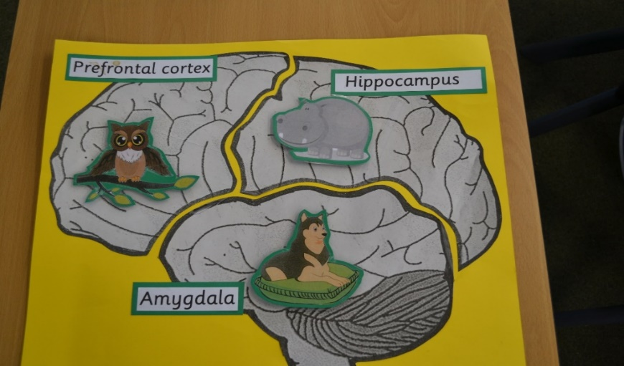

- The Amygdala (The Guard Dog) which is the emotional hub of the brain. The guard dog provides you with security and safety if in danger. He needs to be calm if the other parts of the brain are to function effectively
- The Prefrontal Cortex (The Wise Owl) which is the thinking part of the brain where good choices and plans are made. The children are taught that if the guard dog is not calm then the owl starts to get flustered and thinks about flying off. This explains why when we are anxious or stressed we can’t think clearly and find it hard to learn.
- The Hippocampus (The Hippo). The owl and the hippo are friends and work together. When the owl brain is thinking the hippo stores all the learning.
It has been proven that having a Growth Mindset can improve children’s progress and attainment. As a result, we are teaching our children that by having a Growth Mindset they can grow their brains and intelligence and knowledge are more likely to achieve!

What is a fixed or growth mindset?
The theory behind Growth Mindset is based on the premise that two types of mindsets exist that children and adults may possess, a ‘fixed’ mindset and a ‘growth’ mindset.

Fixed Mindset | Growth Mindset
I like my work to be easy. | I like my work to be difficult – it means I am learning.
I don’t like to try a challenge. | I love challenges.
I want people to praise me for how clever I am. | I want people to praise me for the effort I put into my work.
I believe I cannot change how clever I am. | I believe I can get more intelligent by working hard.
I don’t like to try new things because I won’t be very good at it. | I feel clever when I’m learning something new.
I give up easily. | I never give up.
I don’t like making mistakes. | I learn from my mistakes.

Top tips for supporting your child at home
- Praise the amount of effort your child is putting into things rather than how clever they are.
- Talk to your children about their brain being like a muscle - the more they use it, the stronger it gets (and the more connections are made in your brain).
- Encourage your children to not give up if they are finding something difficult; instead encourage them to embrace challenges.
- Challenge your children to try something new or challenging. Remind them that it will 'develop connections in their brains'.
- Be a growth mindset role model. Make sure you’re sending the right message –try adding the word 'yet' when your child says they can't do something.

